**Q. Write a Problem Analysis Chart (PAC), Algorithm and Flowchart for calculating the area of a circle.**

PAC

|  |  |  |  |
| --- | --- | --- | --- |
| **Data** | **Processing** | **Output** | **Solution Alternatives** |
| Radius | Area = π*Radius*Radius | Print Area |  |

Algorithm

* Start
* Use variable **Radius**, **Area**
* Read **Radius**
* Calculate **Area** = π*(Radius**2)
* Print **Area**
* Stop

Flowchart

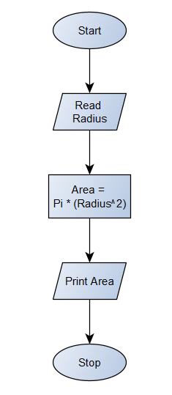

Python Program

import math  
Radius = float(input(**"Enter the radius of the circle : "**))  
Area = math.pi*(Radius**2)  
print(**"The Area of the circle is :"**, round(Area, 2))